Southeast Stock Horse Association
RULES AND GUIDELINES 2019
(Changes highlighted in yellow)
Southeast Stock Horse Association (hereby referred to as SESHA) was established to promote the versatile horse and rider through education and skill development of equine disciplines. In the day of specialized disciplines in the horse world, we have somewhat lost the true versatility of the western horse. The (versatile horse) concept is best defined as a willing equine partner that is comfortable in multiple areas in competition and work. Competitions based on these disciplines provide a format to measure the progress of both horse and rider in a friendly atmosphere. The comradery and fellowship of like-minded individuals with a desire to learn and compete provide an atmosphere that is second to none. Nowhere in the horse business will you find more people that are encouraging you, cheering you on, and supporting your efforts of improving your horsemanship and competition skills. Each show will include, on the first day, an affordable clinic featuring accomplished professional horsemen teaching horsemanship and stock horse principles to advance your skills. These shows are designed to accommodate from the beginning to advanced horsemen and horsewomen and provides classes from entry level to advanced riders and horses. SESHA is proud to provide a venue to facilitate friendly, economical, and educational equine competitions.
GENERAL RULES
SAFETY
Any unmanageable horse will be asked to leave the grounds. This applies to all horses, but especially to Stallions. Any competitor or clinic participant riding a horse that is out of control will be asked to leave the premises. Judges will have the authority to blow a whistle at any time to stop and or excuse any exhibitor who is not in control of their horse. This is especially critical in the working cow class where the goal of this class is for the horse/rider to control the cow. To accomplish this goal, the exhibitor MUST be in control of their horse. Safety to the cattle is also important. Excessive “roughing” behavior, as deemed by the judge in cattle events, will result in stopping the run and scoring the run up to that point. It is the responsibility of the judge to determine if the rider has the “working advantage” while judging the cow work class. As such, failure to maintain the working advantage in the cow class, which could result in the injury of cattle, will be stopped immediately; cattle will at no time be “crashed” into the fence or “roughed”. Responsible stockmanship, including roping, is a must. Crippling, injuring an animal as a result of negligent or excessive rough behavior of the cattle will result in a fine to the competitor of no less than what that particular calf would cost to replace. Dogs are not allowed closer than 10 feet to the arena fence, must be on a leash, and not be left unattended in the stands. In the case of a fallen horse (defined as the horse on the ground with all four feet pointed the same direction) or rider (defined as no longer astride the horse) the run will end at that point and judges will give credit for the work performed to that point. Horse and rider may be checked for injuries and asked to leave the arena as soon as reasonably and safely possible.
EQUIPMENT AND ATTIRE
Equipment
Horses shall be shown in a stock saddle. Silver equipment will not count over good clean, working equipment. Horses, of all ages, may be shown in a ring snaffle, bosal, or curb bit. Split reins shall be used on all bits except that a romal is acceptable with a curb bit and a mecate type rein is acceptable on ring snaffle bits and hackamores (bosal). No more than one finger is allowed between non-romal reins with curb bit.
No fingers between the reins are allowed with a romal. Curb chains or straps must be attached with nylon string, leather, or leather straps. No metal to metal will be allowed. No wire curbs are permitted, regardless of the amount of padding or tape. Absolutely no iron will be permitted under the jaws.
Prohibited equipment includes tie down’s, gag bit’s, cavessons, mechanical hackamores and running martingales. A judge may prohibit the use of any equipment deemed to be inhumane.
At the conclusion of an exhibitors run the judge may ask the exhibitor to present his/her bridle for inspection if the equipment appears questionable. When a bit is used, the mouthpiece must be at least 5/16" and not more than ¾ “in diameter measured one inch from cheek and must be smooth. Nothing may protrude below the mouthpiece such as extensions or prongs. A standard western curb bit must not be longer than 8 ½ inches measured on the outside length from the top bridle attachment to the rein attachment. The port must not be higher than 3 ½ inches with rollers and covers acceptable. Broken mouthpieces, halfbreeds and spades are standard.
Attire
Riders shall wear protective headgear or western hats, long-sleeved shirt with button/snap (completely down front) and collar and western boots. Western boots shall include typical cowboy boots and lace-up ropers. All other footwear is prohibited. The use of spurs and chaps shall be optional. Clothing should be neat and clean.
LIABILITY
SESHA, sponsors, co-sponsoring organizations or Facility, facility management or employees if any, shall not be responsible for any personal injury, or for loss or damage to property, occurring at any association activity. Each owner, exhibitor, handler, or consignor shall indemnify and hold harmless the association, its officers, directors and employees from and against all claims, demands, causes of actions, and expenses of every kind, including attorney’s fees, arising out of or related in any manner to the acts or omissions of an owner, exhibitor, handler, or consignor, or the actions of any animal under the care, custody or control of the owner, exhibitor, handler or consignor. Presentation of signed entry or consignment forms shall be deemed acceptance of the conditions of this rule. In the event an entry or consignment form is not signed or presented, appearance on the grounds or at the sale ring of any association activity as an exhibitor, handler, owner, or consignor shall be deemed to be acceptance of the conditions of this rule.
DISCLAIMER OF RESPONSIBILITY FOR SAFETY OF SHOW OR EVENT PARTICIPANTS
The Association does not assume or accept duty or responsibility for safety at this show/event in regard to participants or any other third parties, or for the horses or other property thereof.
As an express condition of the privilege to participate at a SESHA approved or sponsored show or event, each owner of a horse, exhibitor, trainer, participants, assume the risks of participation and release and discharge the SESHA, its officers, directors, representatives and employees from any and all liability, whenever or however arising as to personal injury or property damage, occurring as a result of participation in a show/event conducted by the show/event or on the show/event grounds thereof.
Without assuming the affirmative duty to monitor possible physical or mental handicaps of exhibitors, if condition of exhibitors’ physical or mental disability comes to the attention of the Association, the individual may be denied participation privileges in SESHA approved events until such time as he or she provides the Association with sufficient information to conclusively establish physical or mental capability to participate, without posing a significant risk to the health or safety of the individual and/or the other exhibitors of the class in which he or she desires to participate. At Association’s sole discretion, the individual may be authorized to use special equipment to enhance physical ability to safely exhibit in Association approved or sponsored shows/events.
EXHIBITOR CONDUCT
No exhibitor shall approach a judge during a SESHA competition except through a show official. An exhibitor may make a request through a show official for a judge’s opinion or interpretation which can be stated in the presence of a show official at any time, however, at no time should interaction between the exhibitor and the judge be permitted during a competition.
Conduct by participants, exhibitors, trainers, owners, owner's representatives, spectators, and all other persons present on the SESHA event grounds of facilities shall be orderly, responsible, sportsmanlike, and humane in the treatment of horses. Any of these violations will be subject to disciplinary procedures.
INHUMANE TREATMENT
No person may treat a horse in an inhumane manner which includes, but is not limited to:
- Placing an object in a horse's mouth so as to cause undue discomfort or distress.
- Tying a horse in a manner as to cause undue discomfort or distress including, but not
limited to, in a stall, trailer or when longing or riding.

DRUGS AND MEDICATION
The use of any stimulants or depressants is prohibited. Any surgical procedure or drug that could affect a horse's performance or alter its natural conformation is prohibited. (Butazolidin use is legal.)
DISCIPLINARY PROCEDURES
Participants, exhibitors, trainers, owners, owner's representatives, spectators, and all other persons present on the SESHA event grounds of facilities in violation of any conduct, sportsmanship, humane treatment rules will be disciplined by management of SESHA or event sponsor. Disciplinary action may include, but not limited to, banning from future participation, being asked to leave the grounds, Fines or probation at the discretion of show management.
EVENT SPECIFIC RULES
Current negative coggins is required of all horses on event grounds. New entries, or at the first of the show season, owner must provide a photocopy of the horse’s registration papers to keep on file. For unregistered horses, 2 photographs of the horse must be provided with age verification if showing in Junior Horse classes.
Grievances must be presented in writing to the event management.
No exhibitor shall approach a judge during an SESHA competition except through a show official. An exhibitor may make a request through a show official for a judge’s opinion or interpretation which can be stated in the presence of a show official at any time, however, at no time should interaction between the exhibitor and the judge be permitted during a competition.
Each exhibitor will be charged a one time, per year $40.00 adult and youth membership fee. Memberships run from January 1 through December 31 each year. Each current adult member will have membership rights as described in the association by-laws.
TELEVISION AND MEDIA RULES
Attendance at an SESHA sponsored or approved event, in whatever capacity, shall constitute authorization for the Association, its agents, designees, or assigns to photograph, video tape, televise, or record by other means (hereinafter referred to as “photographic material” ) any person or animal on the premises of an Association-approved event, and shall further constitute authorization for the use of such person’s name, voice and biography, or the name, pedigree and performance record of any animal on the premises (hereinafter referred to as “related information”) in conjunction with any photographic material.
The photographic material and related information referred to above may be used in any manner that the Association, in its sole discretion, determines would be beneficial to promoting the purposes and goals of the Association, provided, however, that no photographic material or related information will be used in conjunction with the endorsement of any product unless prior written consent is obtained.
Attendance at a SESHA approved event shall further constitute agreement to the terms and conditions outlined above, and shall constitute a waiver and release, without limitation, of any individual television, radio, motion picture, photographic or other similar rights, including right of privacy, any person or animal may have in or to such photographic material or related information when such information is obtained at an Association approved event by the Association, its agents, designees or assigns.
ENTRIES
Email pre-entry, is encouraged and is the desired method of registration for all events. Entry deadline will be the close of business 7 days preceding the show. Entries taken after the deadline will be assessed a $35 late fee. The only exception is for an exhibitor who has never shown with SESHA. All you need to enter to avoid the late fee is stall reservation and cattle class. Additional classes can be added at the show. This will allow event management to obtain an accurate count of the total cattle needed for the successful completion of the event as well as secure the participant’s “spot”.
Clinic participants who have never shown with the Association in the past will receive 1 free class entry the day after the clinic. If a cattle class is entered the participant must pay the cattle charge.
Entries are limited on a “first come, first serve” basis. Entries for special events and jackpots will be one hour before the event at the show office. Entries may be limited in Cattle Classes. Available spots in clinics and other educational events will be announced through the advertisement associated with those events. After all entries are filled, an alternate list shall be generated. In the event an exhibitor is unable to attend the event and has pre-registered and that spot cannot be filled from the waiting list they will be responsible for the entry fee for the clinic and must be paid within 10 calendar days.
Classes may be added the day of the show at the discretion of the show secretary. Absolutely no entries will be taken once the class has started.
Any false or misrepresented statement on application or entry shall constitute unsportsmanlike conduct and will subject the applicant, exhibitor, and/or owner of the horse to disciplinary action as deemed appropriate by the management of the event.
Yearend class win awards will be based on the total number of points obtained from a minimum of 4 shows of the respective year. To be eligible for All-Around year end awards a competitor must have participated in more than 50% of shows during the year.
Points shall be kept on the horse and rider combination. Tie-breakers will be established in case of a tie. Hardship Clause – If a participant’s horse dies or becomes permanently disabled in the middle of the year after being shown previously during the year, participant may apply for treatment under this clause. Each case will be reviewed, approved or disapproved individually by SESHA management. If approved, points earned by dead or permanently disabled horse may be rolled over onto another horse that hasn’t been shown that year for yearend awards. Veterinarian certification of death or disability will be required.
COMPETITION DIVISIONS
An approved show offers seven class divisions: Open, Non-Pro, Limited Non-Pro, Jr. Horse, Novice, Green Rider and Junior Youth (18 and Under). Competitions are open to any rider with any horse. Competitions shall be divided into one of the following divisions based entirely on the ability of the rider, regardless of the horse they are riding with the exception of the Jr. Horse division. A rider may show more than one horse in a division, but any high point awards shall be based on a one horse/one rider team. If a rider competes on two horses he/she may win more than one money / points / awards in a class, however, only the points from the highest placing horse will count toward the high point for the show and year-end. The management has the right to review each rider’s skill and ability level to determine a fair division placing. If a rider is asked to move to a different division after the show season starts, the rider can carry over points already earned at previous shows, to count towards year end awards.
OPEN DIVISION
The Open Division is open to any professional or nonprofessional member in good standing with any horse regardless of past winnings. In addition to the normal entry fee, this division may collect and offer jackpot fees, which will be paid back to winners according to the payout schedule below. These jackpot fees may range from a minimum of $10 to a maximum of $20 per class except for special events or championships.

NON-PRO DIVISION
The Non-Pro Division is open to any nonprofessional member in good standing with any horse regardless of past winnings. In addition to the normal entry fee, this division may collect and offer jackpot fees, which will be paid back to winners according to the payout schedule below. These jackpot fees may range from a minimum of $10 to a maximum of $20 per class except for special events or championships.
Non-Pro Eligibility
The rider has not received payment directly or indirectly for riding, training, assisting in training, or showing horse(s) at any time during the past five years. The rider has not received payment directly or indirectly for instructing another person or conducting a seminar in riding, training, driving or showing a horse any time during the past 5 years. The rider has not had any expenses (including lodging, transportation, mileage, etc.) paid by someone other than family members. Premium money won is not considered remuneration. A Non- Pro rider may show in the Open Division without losing Non- Pro eligibility as long as requirements for a Non Pro are still met. Any payment directly or indirectly from the clinic other than normal travel expenses.
LIMITED NON-PRO DIVISION
Exhibitors who qualify as Non-Pro riders may choose to show in this division because of class routine or other personal choice. Exhibitors may also show in the Open or Non-Pro divisions without losing their eligibility in the Limited Non-Pro division. In addition to the normal entry fee, this division may collect and offer jackpot fees, which will be paid back to winners according to the payout schedule below. Riders in this division will work a modified version of the working cow horse class that will not involve turns down the fence, or circling or roping. (See LTD Non- Pro and Junior Horse Working Cow Horse class rules for specifics on rules for this division.)
Eligibility for the Limited Non-Pro Division. An exhibitor is not eligible for Limited Non-Pro Division if either of the following apply:
- Exhibitor has won 2 or more High-Point Championships in Open, Non-Pro, or Limited Non-Pro divisions at any SESHA show or similar association.
- Has won more than 5 points in any breed association (AQHA, APHA, AQHA VRH All Around, etc.); or $200 in a national organization (NCHA, NRCHA, NRHA, RHAA, etc.) in any western performance discipline (western pleasure, working cow horse, reining, cutting, trail, etc.)

If a member loses their limited non-pro eligibility through competition, they may finish that year as a limited non-pro. In the future, the member is eligible only for Non-Pro, Open or Junior Horse Divisions.
NOVICE DIVISION
The Novice Division is reserved for individuals with limited riding and showing experience who wish to learn more about showing in SESHA at a beginner’s pace. New members in SESHA do not necessarily need to ride in the Novice division. Advanced skills may be better suited for one of the other divisions. There will be no jackpot in this division.
Adheres to all non pro eligibility requirements
Eligibility for the Limited Novice Division. An exhibitor is not eligible for Novice Division if either of the following apply:
- Has won 2 or more High-Point Championships in any division at any SESHA show or similar association.
- Has won an End-of -Year All-Around High Point Champion or Reserve All around High Point Champion in any division in SESHA, ASHA, SHOT or similar association.
- Has won more than 2 points in any breed association (AQHA, APHA, AQHA VRH All Around, etc.); or $100 in a national organization (NCHA, NRCHA, NRHA, RHAA, etc.) in any western performance discipline (western pleasure, working cow horse, reining, cutting, trail, etc.).

If a member loses their novice eligibility through competition, they may finish that year as a novice. In the future, the member is eligible only for Limited Non-Pro, Non-Pro, Open or Junior Horse Divisions.
Riders in this division will work Novice and Youth Reining Patterns and a Novice and Youth Working Cow Horse Pattern. The cow horse pattern is a shortened version of cow work which will not involve turns down the fence, circling or roping. (See SESHA Novice and Youth Reining and SESHA Novice and Youth Working Cow Horse rules for specifics on rules for this division.) Stallions are prohibited in this division.
JR. HORSE DIVISION
The Jr. Horse Division will be open to any horses five (5) years and under. Age must be verified. If challenged, a committee will be appointed to mouth the horses. The age of a horse shall be computed on the basis of a calendar year starting January 1 of the year foaled. A junior horse may be shown by a rider from any division.
YOUTH DIVISION
The Youth Division is for ages 18 and Under. The age of the youth will be determined as of January 1st of the calendar year. Youth division will be divided into Jr Youth (13 & Under) and Sr Youth (14-18). Stallions are not permitted in this division.
A horse may be shown in any division by eligible riders, but may not be shown in any class within a division more than once. Any reported violation of division eligibility will be reviewed by the event management. If horse and/or rider are found to be in violation, they may be barred from further events and any awards may be forfeited.
GREEN RIDER DIVISION *NEW for 2020*
The Green Rider division is reserved for riders in their first year of showing SESHA who have less than 1 year of any showing experience period. New members in SESHA do not necessarily need to ride in the Green Rider division. Advanced skills may be better suited for one of the other divisions. There will be no jackpot in this division.
SCORING
A. Scores for each maneuver are scored 0-10 by Stock Horse (1-10 per maneuver). However, 0 is used only if an exhibitor leaves out part of a class or chooses to not attempt a maneuver, a portion of the score for this maneuver may be 0. All maneuvers of a class that are attempted should receive at least a 1. Judging Scale on all maneuvers and obstacles in all SESHA classes, where 1-10 is the scale, should be:
1-4 Major Faults
5-7 Average Quality
8-10 High Quality
B. No horse shall be disqualified except for illegal equipment, obvious lameness, inhumane treatment or misconduct from the rider.
C. In the case of a fall by a horse or rider, the run shall end when the rider or horse falls to the ground. A horse is considered fallen when all four feet are pointing in the same direction. A horse will be given credit for what he has done prior to the fall.
D. In the case of equipment failure that delays competition or becomes unsafe, the run is stopped and the horse is given credit prior to that point.
E. Using two hands on a curb bit or using more than one finger between split reins or any finger between romal reins will result in a two point run content deduction each time there is a violation. Continuous use of two hands on reins with curb bit is a major fault and should be reflected in the maneuver score.
F. Specific deductions are listed with each class.
G. POINT SYSTEM: The judge must place each class in its entirety. The judge should avoid ties, one-half points are permissible. Specific maneuvers will be designated by the judge to be tie breakers in a class. The tie breaker maneuvers will be made prior to the start of the class and so noted on score sheets for show secretary to use in breaking ties in the class. Every horse in the class is awarded one point for each horse they beat, plus one point. (Examples: In a ten horse class, the first place horse gets ten points and the tenth place horse gets one point. In a five horse class the winner gets five points and the last place horse gets one point.) Disqualified horses will count as entries in the class, but will not receive points (A class with a disqualified horse: In a twenty one horse class where one horse is disqualified, the first place horse gets twenty one points, the twentieth place horse gets two points and the disqualified horse gets 0 points. The last point is not given because the disqualified horse gets no points.) This system will be used for any size class and may include more than one disqualification.
H. High Point ties for each competition and year end awards will be broken by awarding the high point award to the horse/rider with the highest placing in the working cow horse class. If this doesn’t break the tie, the other classes will be used in the following order, reining, trail and ranch riding.

SESHA JUDGING PROCEDURES
Ties for the all-around winner are broken first using the highest score in the working cow horse class, second using the reining class, and then the trail and ranch riding classes.
SESHA ENTRY FEES AND PAYBACK SCHEDULE
Entry Fees for each class will be $30 per class, with a $5 discount for Youth division, a $10 discount for Green Rider Division, plus an office charge of $20 per horse.
Cattle charge for Working Cow Horse classes may vary due to varying cost to the show management.
Membership fee will be $40 for adult and for youth.
Jackpot – Open, Non-Pro and Ltd Non-Pro will have an additional jack-pot fee ranging from $10 to $20 that will be paid back 100% as this payout schedule:

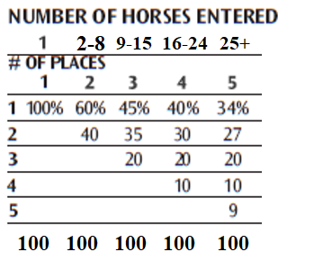

Extra Jackpot - Open division riders have an option to sign up for an Extra Jackpot, which will be separate from the regular Jackpot. 100% of the Extra Jackpot will go to the highest placed Extra Jackpot paid competitor of each class.

Ranch Cutting jackpot fees may vary according to the wishes of the majority of the participants.
Stall rental, RV hook-ups and shavings fee will be site specific.
Additional Jackpots held the weekend of the show will be held that are independent of the show and not point counting. The jackpots may vary in entry fees based on the particular jackpot. The fees will be comprised of an office charge and a jackpot fee (paid back 70% - 45% to class winner, 25% to second place) and a cattle charge if applicable. There will normally be a class breakdown of an open class (which will include Open, Non-Pro, ltd. Non-Pro and Jr. Horse participants) and a novice class (which will include those eligible for the Novice and Youth classes).
SESHA Ranch Trail Class
A horse is ridden through a pattern of obstacles which should nearly approximate those found during the course of everyday work. The horse is judged on the cleanliness, neatness and promptness with which the obstacles are negotiated, ability to negotiate obstacles correctly and attitude and mannerisms exhibited by the horse while negotiating the course. Emphasis on judging should be on identifying the well-broke, responsive, well-mannered horse which can correctly negotiate the course. When setting courses, the management will keep in mind that the idea is not to trap a horse, or eliminate it by making an obstacle too difficult. All courses and obstacles are to be constructed with safety in mind so as to eliminate any accidents.
COURSE REQUIREMENTS, DEVELOPMENT & POSTING
The trail class will be conducted on natural terrain outside of an arena if possible. An outside natural terrain provides a more realistic setting in which a horse may negotiate a pattern of obstacles. This tests the horse’s ability to cope with many situations encountered in everyday riding. In case of inclement weather or extenuating circumstances, the trail class may be held in an arena.
Course will include no less than six and no more than nine obstacles. It is mandatory that the horse be asked to walk, trot and lope during the course in Open, Non-Pro, Ltd. Non-Pro, Junior Horse and Senior Youth Divisions. It is mandatory that the horse be asked to Walk and Trot only in the Junior Youth, Novice and Green Rider Divisions. The walk can be part of obstacle score and scored with approaching obstacle. The trot should be at least 35ft and scored with approaching obstacle. The lope should be at least 50ft and scored with approaching obstacle and be lead specific.
Care must be exercised to avoid setting up of any obstacles that may be hazardous to the horse or rider.
Judges must walk the course and have the right and duty to alter the course if it is not in keeping with the intent of the Stock Horse concept. Judges may remove or change any obstacle they deem unsafe, non-negotiable, or unnecessarily difficult. If at any time a trail obstacle becomes unsafe during a class, it shall be repaired or removed from the course. If it cannot be repaired and some horses have completed the course, the score for that obstacle shall be deducted from all previous works for that class.
Printed handouts for contestants will be handed out prior to the class. The course may be walked on foot by the exhibitor or, in the case of outdoor courses, be observed from the outside of the course on horseback, but no horse/rider exhibitors are allowed on the actual course after it has been set until their trail run begins.
TRAIL CLASS OBSTACLE REQUIREMENTS:
Course will be designed using the mandatory obstacles and maneuvers plus optional obstacles. Combining of two or more of any obstacles is acceptable. Prohibited obstacles: Tarps, water obstacles with slick bottoms, PVC pipe used as a jump or walk over, tires, rocking or moving bridges, logs or poles elevated in a manner that permits such to roll in a dangerous manner. Animals (live or stuffed) should only be used which would normally be encountered in an outdoor setting and which are not used in an attempt to “spook” a horse.
Mandatory obstacles or maneuvers:
Ride over obstacles on the ground – usually logs or poles. It is recommended that all three gaits (walk, trot, and lope) be used, however only two gaits are required.
Walk-Overs. Walk over no more than five logs or poles. The space between logs for walk-overs should be 20 – 24” apart and no more than 10“ high. These can also be in a straight line, curved, zigzagged or raised.
Trot–Overs. Trot over no more than five logs or poles. The space between trot- overs should be 36-42”. Poles may be elevated a maximum of 10”. These can also be in a straight line, curved, zigzagged or raised.
Lope-Overs. Lope over no more than five poles. The space between lope-overs should be 6’ to 7’. Poles may be elevated a maximum of 10 “. These can also be in a straight line, curved, zigzagged or raised.
Opening, passing through, and closing gate. A gate should be used that will not endanger horse or rider and requires minimum side passing. Green Rider will only be asked to place their hand on the gate for few seconds, without having to open it, pass through or close it.
Ride over wooden bridge. (Suggested minimum width shall be 36” wide and at least six feet long). Bridge should be sturdy, safe and negotiated at a walk only. Heavy plywood lying flat on the ground is an acceptable simulation of a bridge.
Backing obstacles – Backing obstacles are to be spaced a minimum of 28” spacing. If elevated, 30” spacing is required. Back through and around at least three markers. Back through L, V, U, straight or similar shaped course. May be elevated no more than 24”. A Green Rider’s pattern will only call for a straight line back up.
Side pass obstacle – Any object which is safe and of any length may be used to demonstrate responsiveness of the horse to leg signals. Raised side pass obstacles should not exceed 12“. A side pass is not required for the Green Rider division.
Rope drag – For Open, Non-Pro, Limited Non-Pro and Junior Horse Classes ONLY. A rope drag is not to be used in Green Rider, Novice or Youth classes. Drag of an obstacle will be performed as drawn on the pattern and at a prescribed gate; either the walk or trot will be designated.
Junior Horse - Distances may be adjusted for Junior Horses only, if so desired. Optional obstacles: New obstacles may be added at any time, we welcome any new and different tests which exhibitors may come up with provided they can be found in everyday ranch work. Following is a list of optional obstacles from which selections can be made, but not limited to:
1) Jump - An obstacle whose center height is not less than 14” high or more than 24” high. Holding the saddle horn is permissible for this obstacle
2) Carry object from one part of the arena to another
3) Remove and replace materials from mailbox
4) Trot through cones – spacing to be minimum of 6’
5) Cross Natural ditches or up embankments
6) Swing rope – throw rope at dummy steer head.
7) Step in and out of obstacle
8) Put on slicker or coat
9) Stand to mount with mounting block
10) Walk over water obstacle
11) Open gate on foot
12) Pick-up feet
13) Walk through brush
14) Ground Tie
15) Lead at the trot.

Scoring Stock Horse Trail
The rider has the option of eliminating an obstacle and taking a score of “0” for the missed obstacle. A judge may ask a horse to pass on an obstacle after three refusals or for safety concerns.
Trail Credits:
Credit is given to horses negotiating the obstacles with style and some degree of Speed, providing correctness is not sacrificed.
Horse should receive credit for showing attentiveness to obstacles and capability of picking their own way through the course when the obstacles warrant it, and willingly responding to the rider’s cues on more difficult obstacles.
Quality of movement and cadence should be part of the maneuver score for the obstacle.
Trail Deductions:
Minor Deductions:
- Artificial appearance and/or unnecessary delay while approaching or going through obstacles.
- Each tick of an obstacle
- Break of gait at walk or jog
- Placing both front or hind feet in a single-stride slot or space
- Skipping over or failing to step into a required space
- Split pole in lope-over
- Stepping on a log, pole, cone or obstacle

Major Deductions:
- Wrong lead or breaking gait at lope
- Stepping outside the confines of, falling off or out of an obstacle such as a back thru, bridge, side pass, box, or water box
- Refusals, balk, or attempting to evade an obstacle by shying or backing
- Blatant disobedience (kicking out, bucking, rearing, striking)
- Failure to ever demonstrate correct lead or gait, if designated
- Failure to complete obstacle

SESHA Reining Class
This class measures the ability of the western stock horse to perform many basic handling maneuvers.
Patterns
This class has four recognized regular patterns, two patterns designed specifically for the Novice & Youth divisions and two patterns for the Green Rider. Management will determine which patterns shall be run. Management may provide an alternate pattern other than the handbook patterns.
Maneuvers
The patterns are broken down into either 7 or 8 maneuvers to be scored a maximum of 10 points each. These maneuvers include stops, spins, rollbacks, circles, backup, hesitation, lead changes, run-arounds and run downs;
Stops are the act of slowing the horse from a lope to a stop position by bringing the hind legs under the horse in a locked position sliding on the hind feet. The horse should enter the stop position by bending the back, bringing the hind legs further under the body while maintaining forward motion and ground contact and cadence with front legs. Throughout the stop, the horse should continue in a straight line while maintaining ground contact with the hind feet
Spins are a series of 360-degree turns, executed over a stationary (inside) hind leg. Propulsion for the spin is supplied by the outside rear leg and front legs and contact should be made with the ground and a front leg. The location of hindquarters should be fixed at the start of the spin and maintained throughout the spins.
Rollbacks are the 180-degree reversal of forward motion completed by running to a stop, rolling (turning) the shoulders back to the opposite direction over the hocks and departing in a canter, as one continuous motion. There should be no hesitation; however a slight pause to regain footing or balance should not be deemed hesitation. The horse should not step ahead or backup prior to rolling back.
Circles are maneuvers at the lope (or a trot in the Green Rider division), of designated size and speed, which demonstrate control, willingness to guide and degree of difficulty in speed and speed changes. Circles must at all times be run in the geographical area of the arena specified in the pattern description and must have a common center point. There must be a clearly defined difference in the speed and size of a small, slow circle and a large, fast circle and the speeds to the left and right should be consistent.
Backup is a maneuver requiring the horse to be moved in a reverse motion in a straight line a required distance, at least 10 feet.
To hesitate is the act of demonstrating the horse's ability to stand in a relaxed manner at a designated time in a pattern. In a hesitation, the horse is required to remain motionless and relaxed. Reining patterns require a hesitation at the end of the pattern to demonstrate to the judge(s) the completion of the pattern.
Lead Changes are the act of changing the leading legs of the front and rear pairs of legs, at a lope, when changing the direction traveled. The lead change must be executed at a lope with no change of gait or speed and be performed in the exact geographical position in the arena specified in the pattern description. The change of front and rear leads must take place within the same stride to avoid deductions. Lead Changes are not included in the Green Rider Division.
Run-arounds and Run downs are runs through the middle of the arena and runs along the side and ends of the arena. Run downs and run-arounds should demonstrate control and gradual increase in speed to the stop.
Scoring Stock Horse Reining
Credits:
- Overall smoothness of pattern
- Degree of difficulty exhibited by stops, spins and rollbacks and speed in circles and run-outs.
- Horse should guide willingly without undue resistance.
- Lack of set-ups or anticipations in the execution of any of the maneuvers.
- Exhibiting finesse, attitude, quickness, authority and controlled speed while completing a correct maneuver

Deductions: to be subtracted from maneuver scores are as follows

Five Point Deductions:
- Blatant disobediences, including kicking, bucking or rearing.
- Spurring in front in cinch or the use of either hand to instill fear or praise.

Two Point Deductions:
- Break of Gait
- Freeze up in spins or rollbacks. A freeze up is any time the lateral movement of horse's shoulders is completely stopped and has to be restarted to complete the maneuver.
- In trot in patterns, failure to stop or walk before executing a canter departure.
- In run-in patterns, failure to be at a canter before first marker
- Failure to completely pass a specified marker before initiating a stop.
- 6 . Using two hands on a curb bit or using more than on finger between split reins or any finger between romal reins will result in a two point run content deduction each time there is a violation. The free hand may be used to straighten excess rein at any place a horse is allowed to be completely stopped during a pattern.
- Over or under spinning of more than one-fourth turn
- Jogging more than two strides to start circles or exit rollbacks.
- Backing more than 2 strides in any maneuver except the backup

One point Deduction:
- Each time a horse is out of lead. Penalties are cumulative for each occurrence and each one-fourth circle.
One-half point Deduction:
- Jogging less than two strides to start circles or exit rollbacks.
- Failure to maintain a minimum of twenty feet from wall or fence for stops or rollbacks on standard patterns with the exception of Novice & Youth Pattern # 1.
- For one stride delayed lead change
- For exiting the rollback at a trot for up to 2 strides

SESHA Reining Pattern #1

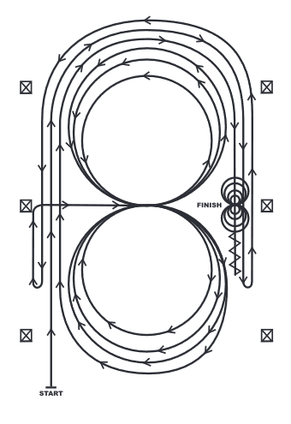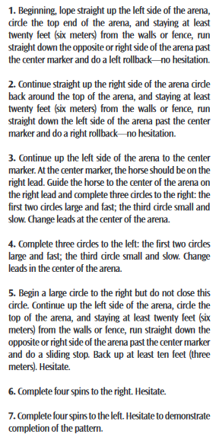

SESHA Reining Pattern #2

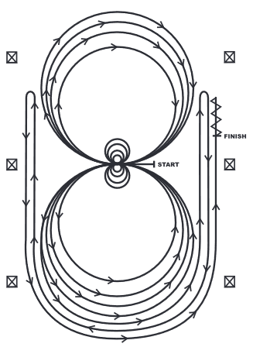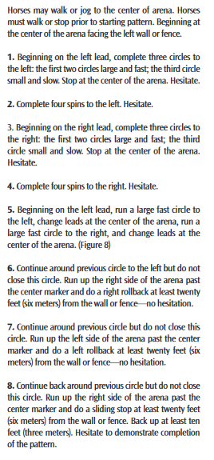

SESHA Reining Pattern #3

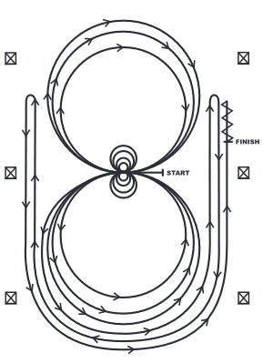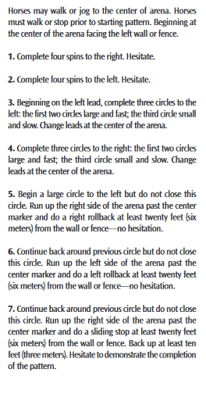

SESHA Pattern #4
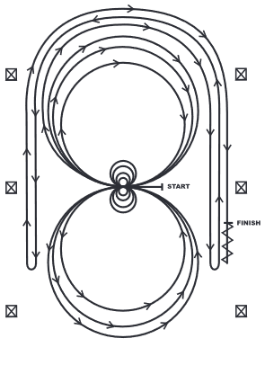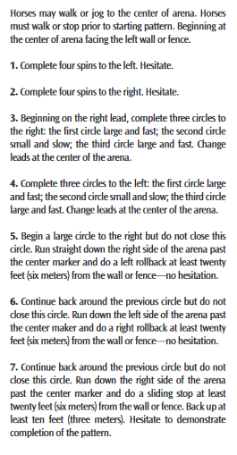

Mandatory Markers:

The judge shall indicate with markers on arena fence the center of the pattern.

SESHA Novice and Youth Stock Horse Reining Pattern # 1
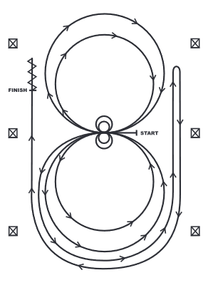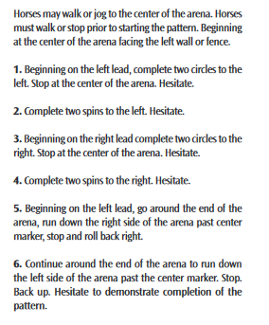

SESHA Novice and Youth Stock Horse Reining Pattern # 2
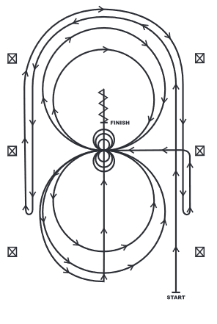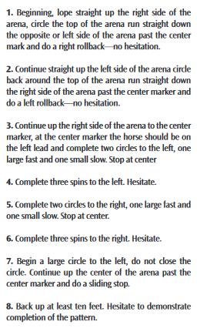

Mandatory Markers:

The judge shall indicate with markers on arena fence the center of the pattern.

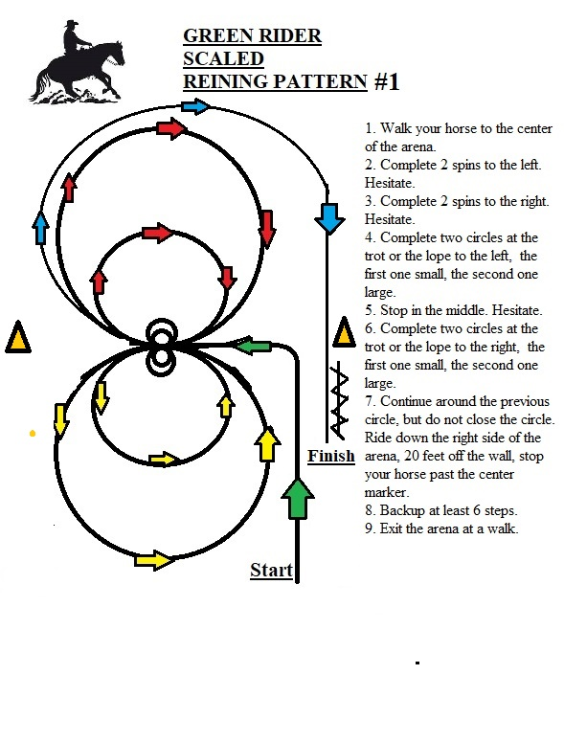

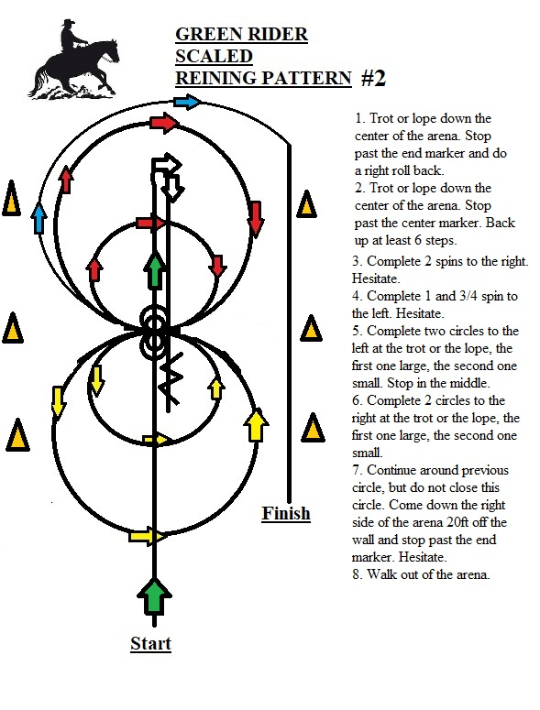

Ranch Riding (AQHA Format)
The purpose of the Ranch Riding horse should reflect the versatility, attitude, and movement of a working horse. The horse’s performance should simulate a horse riding outside the confines of an arena and that of a working ranch horse. This class should show the horse’s ability to work at a forward, working speed while under control by the rider. Light contact should be rewarded and horse shall not be shown on a full drape of reins. The overall manners and responsiveness of the ranch riding horse to make timely transitions in a smooth and correct manner, as well as the quality of the movement are of primary considerations. The ideal ranch riding horse should have a natural ranch horse appearance from head to tail in each maneuver.
Gaits
1. Walk - A stock horse pleasure walk should be straight, square, flat footed, relaxed and should move out freely with horse looking ahead. The extended walk should show more length of stride than the ordinary walk.
2. Trot - This gait should be a square two-beat diagonal trot. The trot should be steady, soft and slow enough for riding long distances. Trots which are rough and hard to sit should be penalized.
Excessively slow and un-cadenced trots should also be penalized.
3. Extended Trot - The extended trot should show an evident lengthening of stride from the regular trot with the same cadence that will cause an increase in speed. This trot should be level, flat and steady with the appearance that the horse would hold this gait for an extended distance.
4. At the preference of the rider, the extended trot may be ridden with the rider posting, sitting or standing in the stirrups, to the front of the saddle. Holding the saddle horn is permissible at the extended trot only. Preference should not be given by the judge for any method of showing, as emphasis should be on the performance of the horse and how effective the horse is at actually extending the trot and the mannerisms and responsiveness to the rider.
5. Lope - This gait should be a three beat gait that is cadenced, straight and steady and is comfortable to ride over long distances. Lope is not required in the Green Rider division.
6. Stop (from both lope and trot) - The horse should be in the correct stopping position, both hocks engaged and stopping on the hindquarters.
7. Reverse - A horse should turn briskly and flat with front feet on the ground and holding an inside rear pivot foot. The reverse may be executed by turning either direction.
8. Extended Lope - This gait should be an obvious lengthening of stride from the previous lope, be at the same cadence and cause an increase in speed while being under control. Extended lope is not required in the Green Rider division.
9. Part of the evaluation of this class is on smoothness of transitions. No credit shall be given for imperceptible cues. To see these cues applied discretely and the horse responding correctly could be a credit earning situation. All transitions should be smooth. Please note the rules allow for a horse to be taken back (collected) a bit from the extended trot as the horse moves into the lope. The transition from the extended lope down to the trot is very difficult to achieve, however, a good stock horse will have to make this transition several times during a day’s work. This transition is down to the normal or sitting trot not the extended trot. Therefore, an extra cue to achieve this gait is expected. Horses that complete this total transition within three strides calmly and obediently should be rewarded. Horses that bring the hocks together to go into a stopping position should be penalized according to the magnitude of the error.

Class Requirements
Each horse will work individually, performing both required and optional maneuvers, and scored accordingly by the Judge.
The required maneuvers will include the walk, trot, and lope both directions: and the extended trot and extended lope at least one direction; as well as stops, and back. Lope and extended lope is not required in the Green Rider division.
Three optional maneuvers may include a side pass, turns of 360 degrees or more, change of lead (simple or flying), walk, trot, or lope over a pole(s); or some reasonable combination of maneuvers that would be reasonable for a ranch horse to perform.
The maneuvers may be arranged in various combinations with final approval by the judge.
The overall cadence and performance of the gaits should be as those described in GAITS, with an emphasis on forward movement, free-flowing, and ground covering for all gaits. Transitions should be performed where designated, with smoothness and responsive-ness.
No time limit.
One of the suggested patterns may be used, however a judge may utilize a different pattern as long as all required maneuvers and the three (or more) optional maneuvers are included. Should a judge use one of his/her own patterns, it is recommended to not have the stop following an extended lope.
The use of natural logs is encouraged.
Posting at the extended trot is acceptable.
Touching or holding the saddle horn is acceptable.

Ranch Riding Apparel and Equipment
No hoof polish.
No braided or banded manes or tail extensions.
Trimming inside ears is discouraged.
Trimming bridle path is allowed, also trimming of fetlocks or excessive (long) facial hair.
Equipment with silver should not count over a good working outfit. Silver on bridles and saddles is discouraged.
It is suggested competitors use a breast collar and a rear cinch.

Ranch Riding Penalties
A contestant shall be penalized each time the following occur:
One (1) point penalties
- Too slow/per gait Over-bridled Out of frame
- Break of gait at walk or jog for 2 strides or less

Three (3) point penalties

- Break of gait at walk or jog for more than 2 strides
- Break of gait at lope
- Wrong lead or out of lead
- Draped reins
- Out of lead or cross-cantering more than two strides when changing leads trotting more than three strides when making a simple lead change
- Severe disturbance of any obstacle

Five (5) point penalties
- Blatant disobedience (kick, bite, buck, rear, etc.) for each refusal and placed below horses performing all maneuvers
- Eliminates maneuver
- Incomplete maneuver

Zero (0) score
- Illegal equipment including hoof black, braided or banded manes, or tail extensions
- Willful abuse
- Major disobedience or schooling
- Lameness
- No specific penalties will be incurred for nicks/hits on logs but deduction may be made in maneuver score.
- No specific penalties will be incurred for over/under spins but deduction may be made in maneuver score.

Scoring
Ranch Riding will be scored using AQHA criteria and scored by Stock Horse (1-10) per maneuver at the management’s discretion.
Scoring Ranch Riding – Each gait or maneuver including transitions, will be scored. The scoring guide for each maneuver, including transitions, is as follows:
Major faults – wrong lead, broken gait, lack of control, failure to perform requested gait, draped reins, etc. will be penalized.
Average quality of movement of gaits and transitions with some or no faults will be scored appropriately.
A High quality mover that is functionally correct in all gaits and transitions, well-mannered and responsive, soft and cadenced in all gaits will be credited.

RANCH RIDING – PATTERN I
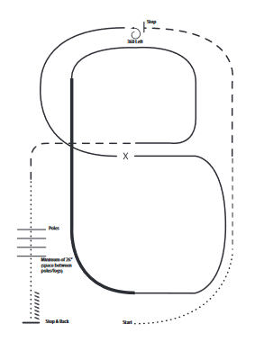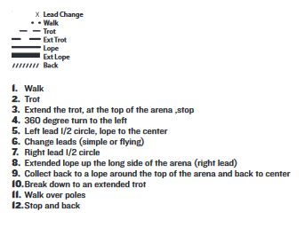

RANCH RIDING – PATTERN 2
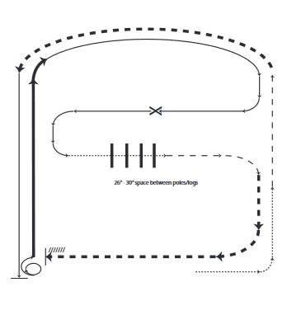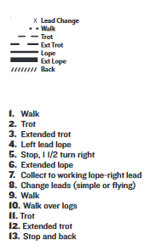

Ranch Riding Pattern 3
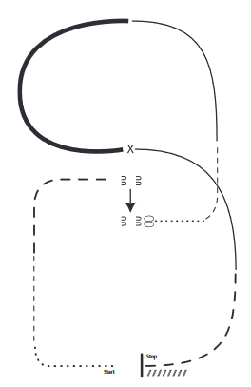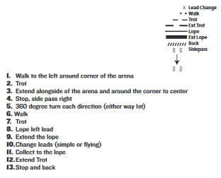

Ranch Riding Pattern 4
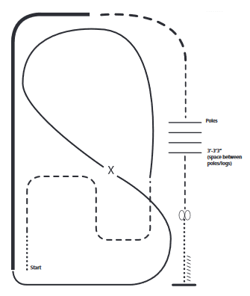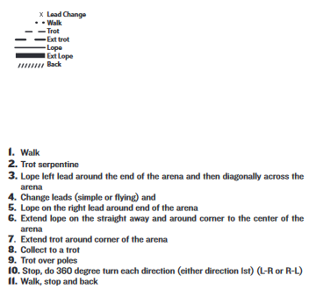

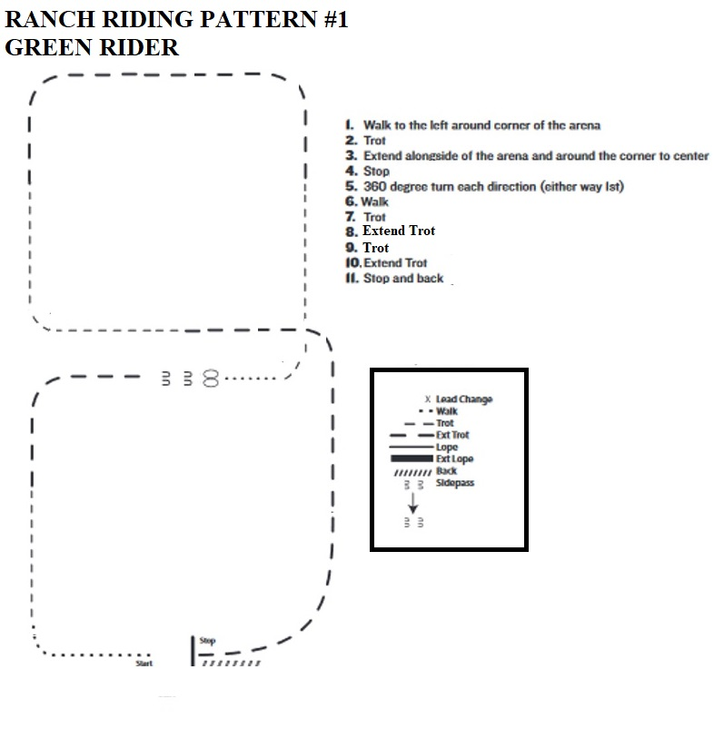

Stock Horse Working Cow Horse Class
A versatile western stock horse must also be a cow horse and this class has been designed to demonstrate and measure the horse’s ability to do cow work. For Open and Non Pro divisions both the cow work portion of this event and the reined work portion are mandatory. For limited Non-pro, Novice, Youth, Green Rider and Junior Horse only the Cow work portion is required. When judging reined work, the judge should refer to the reining portion of the rulebook for guidelines.

Open and Non-Pro Reined Work Pattern 1
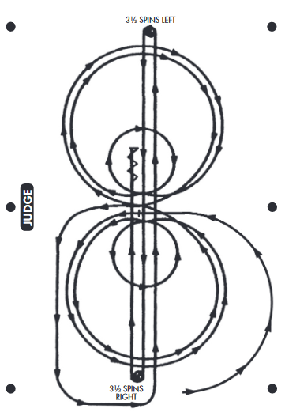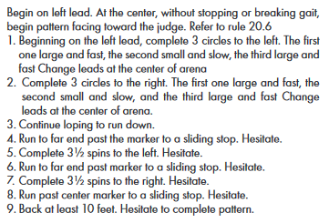
Open and Non-Pro Reined Work Pattern 2

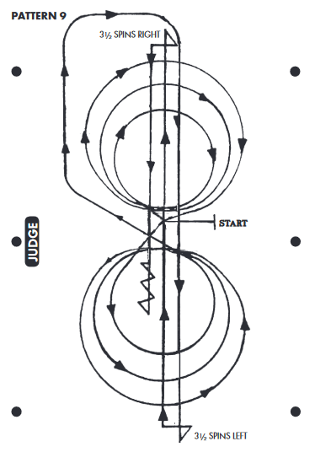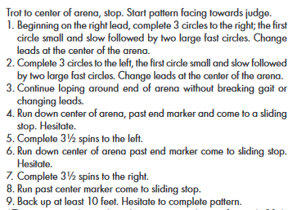
Open and Non-Pro Reined Work Pattern 3
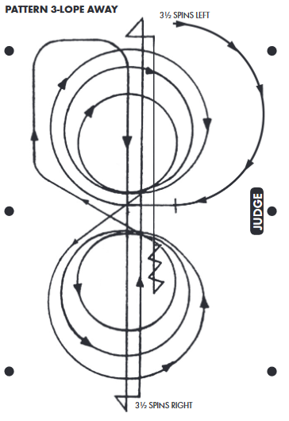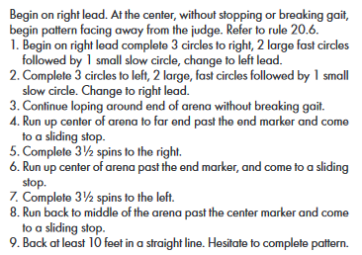
In the Cow Work portion holding the saddle horn is permitted.
Timing will be done by the announcer. At the end of the time limit, the announcer will call time. If the time has not elapsed and the judge is satisfied that all requirements of the class have been met, the judge should blow the whistle for the contestant to quit work.
When enough cows are available the contestant should receive a new cow if the cow drawn is unreasonably difficult or unworkable. Allowing the horse to quit working before the judge signals for a new cow will result in a zero score. Once a rider has committed to circling a cow, if the cow falls down no new cow will be awarded. The rider should complete the run by riding around the fallen cow to fulfill circling requirements.
The judge may blow his/her whistle at any time during the work. One whistle to terminate the work, two whistles to award a new cow. If the judge awards a new cow, the exhibitor has the option to refuse the new cow by continuing to work. If the exhibitor intends to accept the new cow, he or she must pull up immediately. The judge may blow a whistle at any time for the contestant to cease work for safety reasons. Judges will give credit for what they have seen. Only the judge may award a new cow to a contestant. Contestants must continue working until time is called to avoid a run content deduction. Standard deductions that may be applicable throughout all divisions when judging the cow work:
Zero maneuver scores
- Repeated disobedience
- Turning tail to the cow, scoring will cease and the exhibitor will be asked to leave the arena.
- Fall of horse and rider, scoring will cease, exhibitor will be given credit for the run up to that
- point.
- A rider failing to rope or that misses both loops will be given credit for the run to that point, but will receive a zero for the stop and hold portion.
- Loss of working advantage that results in potential injury of the cow.
- Roughing the cattle.

Five point penalties
- Blatant disobedience, bucking, rearing, kicking; First occurrence.
- Spurring in front of the cinch or using hand to instill fear.
- Failure to turn the cow both directions on the fence.
- Use of two hands (except in snaffle bit or hackamore) per maneuver

Two Point Penalties
- Using two hands when riding with a curb bit, this penalty is cumulative.
- Going around the end of the arena to achieve fence turn.

One Point Penalties
- Using side fences to turn cow.
- Losing the cow, falling behind by more than a horse length.

Working Cow Horse Class for Open and Non-Pro Down the Fence. There will be a 3 minute time limit per horse to perform the entire work beginning when the cow is turned into the arena. When there is one minute left on the time, the announcer will announce, “one minute”. At 3 minutes, the announcer will call time. The work in the open and non-pro cow horse class will consist of the following three parts:
- Part One – Boxing the Cow –Rider shall ride into the arena and face the cattle entry gate. The rider shall signal for their cow to be turned into the arena. Upon entry into the arena, the cow shall be controlled on the entry end of the arena for a sufficient amount of time to demonstrate the horse’s ability to “hold” the cow. If the cow does not immediately challenge the horse, the rider shall aggressively move in on the cow to demonstrate his horse’s ability to drive and block the cow on the entry fence.
- Part Two – Fence Work – After the cow has been controlled on the end of the arena, the rider shall deliberately release the cow and drive it down the side of the arena. The cow should be turned on the fence at least once in each direction. The first run out for a turn shall be past the half-way mark of the arena. All turns down the side shall be completed before reaching the end fence.
- Part Three – Optional roping or circling for the third part of this class, the rider has the option to either rope and stop the cow or to take the cow to the middle of the arena and circle it at least once each direction. A rider may circle or rope the cow but cannot combine the two to get credit for this portion of the class. To rope the cow, the rider must be carrying a rope when the class starts. The rider may pull up after the fence work, take down the rope, and proceed to rope and stop the cow. The rider may only throw two loops. The catch is legal as long as cow looks through the loop and the rope pulls tight on any part of the animal’s body except the tail. A no catch does not mean a score of zero for this portion of the class. A horse must be given credit for rating and tracking but should not be scored higher than a horse that has also demonstrated the ability to stop and hold the cow. To circle the cow, the Exhibitor will maneuver the cow smoothly at least 360 degrees in each direction without interference from the fence. The circle’s size, symmetry, speed and relative balance from right and left show control. Tightening the circles down with fast head-to-head speed will be a credit situation. The circles should be completed before the cow is exhausted. Once an Exhibitor has committed to circling a cow, if the cow falls down no new cow will be awarded. The Exhibitor will complete the run by riding around the fallen cow to fulfill circling requirements. In the circling portion of the judging, one whistle will terminate the work, two whistles will award a new cow.
Scoring Open and Non-Pro Down the Fence Working Cow Horse Class
Scoring for the working cow horse class shall be 20 points for each of the three parts of the class with a total of 60 points for the entire class. Each of the three parts of the class is broken into two scores of 10. In selecting tie-breakers, a judge may use 1, 2, and 3,4,5,6 in any order. Scoring columns 5 and 6 for both circling and roping may be given any tie breaker rankings, but should be given the same tie breaker rankings... In other words, give only 6 tie breaker rankings with circling and roping scoring columns being the same
Scoring for Part One – Boxing (Maximum of twenty points)
- The horse will be scored 10 points for control, position and correctness
- The horse will be scored 10 points for degree of difficulty, amount of work done, eye appeal and cow sense.

Credits:
- Expression by the horse and making moves with little rider assistance
- Holding and controlling the cow
- Amount of work actually done and the degree of difficulty of the work
- Horse forces cow to turn

Deductions
- Missing cow badly on turns
- Horse having to be handled excessively
- Letting cow escape to start rundown instead by being held, released, and driven down the Fence.
- Using side fences to turn cow
- Use of two hands (except in snaffle bit or hackamore) per maneuver

Scoring for Part Two – Fence Work (Maximum of twenty points)
- The horse will be scored 10 points for control, position and correctness
- The horse will be scored 10 points for degree of difficulty, amount of work done, eye appeal and cow sense.

Credits:
- First run at least ½ length of arena and past middle marker.
- Turns that are right on the cow
- Controlling a difficult cow

Deductions:
- Making first run less than ½ length of arena
- Using end fences to help turn cow
- Going around the end of arena to get a turn
- Sliding by cow by more than a horse length on turns
- Failure to turn the cow both directions on the fence
- Hanging up on the fence (refusing to turn)
- Use of two hands (except in snaffle bit or hackamore) per maneuver
- Fall of horse/rider (run ends, credit will be given for work done)
- Going around the corner of the arena before turning cow

Scoring for Part Three – Optional Circling or Roping (Maximum of twenty points)
Circling
- The horse will be scored 10 points control, position and correctness
- The horse will be scored 10 points for degree of difficulty, amount of work done, eye appeal and cow sense.

Credits:
- Getting up on cow close enough to control the circles
- Acknowledging the cow during circling and working willingly

Deductions:
Circling
- Lack of control in circles due to distance from cow
- Not acknowledging the cow or simply lack of horse’s ability
- Use of two hands (except in snaffle bit or hackamore) per maneuver

Roping
- The horse will be scored 10 points for rating, position, stop and holding.
- The horse will be scored 10 points for speed, degree of difficulty, eye appeal and cow sense.

Credits:
- Rating and following cow to allow roper the optimum position to rope
- Stopping hard and staying in the ground during the jerk

Deductions:
- Not tracking, not rating and not catching up to the cow
- Poor stop

Working Cow Horse Class for Non-Pro Boxing, Limited Non-Pro, and Junior Horse Divisions (2 Minutes) Non-Pro boxing class will perform the reined work pattern before calling for their cow. Limited Non-Pro and Junior horse is Cow Work only. This class has been developed for non-pro riders and the Junior Horse Division as an intermediate level working cow horse class. There will be a two minute time limit per horse to perform the entire work beginning when the cow is turned into the arena. When there is one minute left on the time, the Announcer will announce, “one minute”. At 2 minutes, the announcer will call time the work in this class will consist of the following three parts. To eliminate Boxing or Fence class having an advantage over the other, the Non-Pro All Around will be computed as follows. The points will be based on the larger number of participants in the Boxing only or the Fence Class. Example: 6 entries in boxing and 3 entries in the fence class. The first place in both classes will receive 6 points, second place will receive 5 points and so on. In the case of a tie, the fence class participant will be placed higher. If an exhibitor enters both the Boxing and the Fence Class, the class with the higher points will count toward the All Around."
Part One – Boxing the Cow – The rider shall ride into the arena and face the cattle entry gate. The rider shall signal for their cow to be turned into the arena. Upon entry into the arena, the cow shall be controlled on the entry end of the arena for a sufficient amount of time to demonstrate their horse’s ability to “hold” the cow.
Part Two – Release cow and drive down the Side of Arena to Opposite End of Arena. After the cow has been controlled on the entrance end of the arena, the rider shall deliberately release the cow and set up for driving down the side of the arena. When coming out of corner, the horse shall be close enough to cow to demonstrate control with cow against the fence. This distance and control should be maintained for approximately three-fourths length of arena. Rider will then back horse off of cow and move horse toward center of arena to set cow up for boxing.
Part Three – Boxing the Cow at opposite end of arena –The exhibitor will again control or “hold” the cow at this end of the arena to demonstrate the horse’s ability to “hold” the cow. Continue boxing until time expires.
Scoring Working Cow Horse class for Non-Pro Boxing, Limited Non-Pro and Junior Horse Divisions
Scoring for the working cow horse class for Limited Non-Pro and Junior horse divisions will be 1 to 50 points based on 20 points for each “boxing the cow “work and 10 points for the drive down the side of the arena. Each of the three parts of the class is broken into two scores. In selecting tie breakers, a judge may use 1 through 6 of the scoring columns in any order.
Scoring for Part One – Boxing (Maximum of 20 points
- The horse will be scored 10 points for control, position and correctness.
- The horse will be scored 10 points for degree of difficulty, amount of work done, eye appeal and cow sense.

Credit
- Expression by the horse and making moves with little rider assistance
- Holding and controlling the cow
- Amount of work actually done and the degree of difficulty of the work

Deductions:
- Missing cow badly on turns
- Horse having to be handled excessively
- Letting cow escape to start rundown instead of being held, released, and driven down the fence of arena
- Using side fences to turn cow
- Use of two hands (except in snaffle bit or hackamore) per maneuver

Scoring for Part Two – Driving down arena fence (Maximum of 10 points)
- To receive full credit for the drive down the cow must be controlled on the fence for at least three - fourths the length of the arena.
- The horse will be scored 5 points for control, position and initiative.
- The horse will be scored 5 points for degree of difficulty, amount of work done, eye appeal and cow sense.

Credit:
- Rating the cow
- Blocking the cow with pressure towards the end of the arena.
- Driving the cow with control down the side of the arena

Deductions:
- Unable to direct cow to opposite end of arena
- Failure to rate the cow and drive against the fence
- Letting cow return to entry gate
- Use of two hands (except in snaffle bit or hackamore) per maneuver

Scoring for Part Three – Boxing (Maximum of 20 points)
- The horse will be scored 10 points for control, position and correctness.
- The horse will be scored 10 points for degree of difficulty, amount of work done, eye appeal and cow sense.

Credit:
- Expression by the horse and making moves with little rider assistance
- Holding and controlling the cow
- Amount of work actually done and the degree of difficulty of the work

Deductions:
- Missing cow badly on turns
- Horse having to be handled excessively
- Letting cow escape
- Use of two hands (except in snaffle bit or hackamore) per maneuver

Working Cow Horse Class for Green Rider, Novice & Youth Divisions
(1 minute to work the cow) A versatile western stock horse must also be a cow horse and this class has been designed to demonstrate and measure a horse’s ability to do cow work. Holding the saddle horn is permitted in this class. This class has been developed for novice and youth riders as an entry level working cow horse class. There is no “dry work” pattern for this class. The rider will enter the arena and signal for a cow. Timing will be done by the announcer starting when the cow is turned into the arena. The rider will have 1 minute to work the cow. At 1 minute, the announcer will call time. The judge may blow a whistle at any time for the contestant to cease work for safety reasons. Boxing the Cow – The rider shall signal for their cow to be turned into the arena. Upon entry into the arena, the cow shall be controlled on the entry end of the arena for one minute to demonstrate the horse’s ability to “hold” the cow. If the cow does not immediately challenge the horse, the rider shall aggressively move in on the cow to demonstrate his horse’s ability to drive and block the cow on the entry fence.
Scoring Green Rider, Novice & Youth Working Cow Horse Class
Scoring will consist of a maximum of 60 points for the class. The boxing will be scored from 1-20 for each of the three components (see below).
Scoring for Boxing (Maximum of 60 points)
- The horse will be scored 1-20 points for control and position
- The horse will be scored 1-20 points for eye appeal and cow sense
- The horse will be scored 1-20 points for degree of difficulty and amount of work done

Credit:
- + Expression by the horse and making moves with little rider assistance
- + Holding and controlling the cow
- + Amount of work actually done and the degree of difficulty of the work

Deductions:
- - Missing cow badly on turns
- - Horse having to be handled excessively
- - Letting cow escape
- - Use of two hands (except in snaffle bit or hackamore) per maneuver

RANCH CUTTING RULES
Ranch Cutting may or may not be offered at each show. Points do not count toward the All-Around.
General Rules
Classes
Open – Eligible to anyone, including professional trainers who have shown, trained or received compensation for training cutting horses for the general public in the last 6 months. Horse eligibility is any horse regardless of winnings. 2-1/2 minute time limit.

Ranch Class – Eligible to experienced rider or trainer, but who has not received money for training Cutting Horses in the past 5 years. This class is designed for the Stock Horse Show participants who do not normally show in cutting competitions. This class is to showcase Stock horses exhibiting normal sorting skills of the working horse. 1-1/2 minute time limit. Horse eligibility for Ranch Class – May be professionally trained, but with no NCHA or ACHA earnings, only exception would be if he is entered in a minimum of 2 Stock Horse Show classes the following day.
Novice Class – Any rider that has never trained horses professionally, received compensation for instruction or been a paid employee for a professional trainer. This class is designed to be an entry level class for those people starting out. (You are not eligible for this class if you have ever received money for riding a horse.) 1-1/2 minute time limit.
Novice horse eligibility – May be professionally trained, but with no NCHA or ACHA earnings, only exception would be if he is entered in a minimum of 2 Stock Horse Show classes the following day.
Youth –18 years of age or younger as of January 1st of the show year. Herd work is required. Same rules as Ranch and Novice class.
Youth Horse eligibility – No stallions may be shown in Youth Class. May be professionally trained, but with no NCHA or ACHA earnings, only exception would be if he is entered in a minimum of 2 Stock Horse Show classes the following day.
• Any youth that has NCHA, ACHA or SESHA cutting earnings in excess of $1,000 combined earnings is not eligible for the youth division.
Open Class
1. Cutters will have 2 ½ minutes to complete their run.
2. The announcer will announce the cutter’s name and Time will begin when contestant crosses the starting line. The announcer will inform the Cutter when 2-1/2 minutes are up and call time. Cutters should stop immediately when time is called. Each Cutter may use two herd holders and two turn back men.

3. All Cutting events are judged using a modified version of the NCHA’s official rules. The modifications will pertain only to scoring as it relates to reining a horse. Contestants are responsible for familiarizing themselves with these rules; i.e. back fence, hot quit, losing a cow, scattering a herd, position penalties, etc. When discrepancies arise, the NCHA rule book will govern with the exception of the conditions stated in these rules.

4. Consideration shall be given to the content of the run completed without reining a horse. A participant excessively reining a horse or using direct force by jerking or pulling a horse around may be penalized. Participants using one hand will be given consideration over those using two hands. Snaffle bits must be used as two handed. This rule may be subject to each individual Judge’s interpretation.

5. Cutter may cut up to a maximum of three head during his 2 ½ minutes.
6. Herd holders and turn back men are subject to same dress code and NCHA rules.
7. Dress code while competing will be a button up shirt with a collar, long sleeve shirts, western boots and a western hat. Chaps are optional.
8. Judging will be by NCHA format with the exception of the reining provision.
9. This class does not carry over any points to the all-around championships of the respective show.
10. These classes are provided for the enjoyment of the participants and may or may not be offered at all shows.

Ranch Class
1. Cutters will have 1-1/2 minutes to complete their run.
2. The announcer will announce the cutter’s name and Time will begin when contestant crosses the starting line. The announcer will inform the Cutter when one minute is remaining and then call time. Cutters should stop immediately when time is called. Each Cutter may use two herd holders and two turn back men.
3. All Cutting events are judged using a modified version of the NCHA’s official rules. The modifications will pertain only to scoring as it relates to reining a horse. Contestants are responsible for familiarizing themselves with these rules; i.e. back fence, hot quit, losing a cow, scattering a herd, position penalties, etc. When discrepancies arise, the NCHA rule book will govern with the exception of the conditions stated in these rules.
4. Consideration shall be given to the content of the run completed without reining a horse, but in the Ranch Class reining a horse is expected. A participant excessively reining a horse or using direct force by jerking or pulling a horse around may be penalized. Participants using one hand will be given consideration over those using two hands. Snaffle bits must be used as two handed. This rule may be subject to each individual Judge’s interpretation.
5. Cutter may cut up to a maximum of two head during his 1-1/2 minutes.
6. Herd holders and turn back men are subject to same dress code and NCHA rules.
7. Dress code while competing will be a button up shirt with a collar, long sleeve shirts, western boots and a western hat. Chaps are optional.
8. Judging will be by NCHA format with the exception of the reining provision.
9. This class does not carry over any points to the all-around championships of the respective show.
10. These classes are provided for the enjoyment of the participants and may or may not be offered
at all shows.

Novice – Same rules as the Ranch Class.
Youth –18 years old or younger. Same rules as the Ranch and Novice Class.
Entries
Entries will close 1 hour before the scheduled cutting.
Fees for open, Ranch and Novice will consist of $25 entry fee + cattle charge (may possibly vary according to availability. Jackpot fee is $25 for open class, $25 for Ranch and $10 for Novice and youth.
Jackpot fees are subject to change depending on the participants wishes. Cattle charge may fluctuate depending on the cost of cattle to the show management.
RANCH RAIL PLEASURE
Not an All-Around Class
Open, Non-Pro, Limited Non-Pro may show Concurrently but each division will be placed individually.
Green Rider – this class cannot be combined with other divisions to run it concurrently. This Division will be Walk-Trot-Extended Trot only.
Novice, Youth, Jr Horse may show Concurrently but each division will be placed individually.
A. Open to horses three years of age and older.
B. This class is intended as a rail class but individuals working off the rail will not be penalized.
C. The ranch rail pleasure class measures the ability of the horse to be a pleasure to ride while
being used as a means of conveyance from one ranch task to another and should reflect the
versatility, attitude, and movement of a working horse. The horse should be well-broke,
relaxed, quiet, soft and cadenced at all gaits. The horse should be ridden on a relatively
loose rein with light contact and without requiring undue restraint. The horse should be
responsive to the rider and make timely transitions in a smooth and correct manner. The
horse should be soft in the bridle and yield to contact maintaining a natural head carriage at
each gait.
D. In all gaits, movement of the ranch rail pleasure horse should simulate a horse needing to
cover long distances, softly and quietly, like that of a working ranch horse. This class should
show the horse’s ability to work at a forward, working speed while under control by the rider.
Light contact should be rewarded and horse shall not be shown on a full drape of reins. The
overall manners and responsiveness of the horse while performing the maneuver
requirements and the horse’s quality of movement are the primary considerations.

The following terminology shall apply:
Walk – The walk is a natural, at footed, four-beat gait. The gait is rhythmic and ground-
covering. As in all gaits, the horse should dis- play a level, or slightly above level topline with
a bright, attentive expression.
Trot – The trot is a natural two-beat gait demonstrating more forward motion than the
western jog.
Extended Trot – The extended trot is an obvious lengthening of the stride with a definite
increase in pace. The horse should be moving in a manner as if it were covering a large area
on a ranch with an above level topline.
Lope – The lope is a three-beat gait. The lope should be relaxed and smooth with a natural,
forward moving stride. Not required for the Green Rider Division.
Extended Lope – The extended lope is not a run or a race but should be an obvious
lengthening of the stride, demonstrating a forward, working speed. The horse should display
an above level topline with a bright, attentive expression. Not required for the Green Rider Division.
E. Part of the evaluation of this class is on smoothness of transitions. A horse may be collected
from the extended trot as the horse moves into the lope. The transition from the extended
lope down to the trot is a transition to the seated trot not the extended trot. Therefore, an
extra cue to achieve this gait is expected. Horses that complete this total transition within
three strides calmly and obediently should be rewarded. Horses that attempt to stop or do
stop prior to trotting will be penalized. Judges expect to see horses that have been trained to
respond to cues. To see these cues applied discretely and the horse responding correctly
could be a credit earning situation.
F. Ranch Rail Pleasure Penalties. A contestant shall be penalized each time the following occur:
a. Too slow/per gait
b. Over-bridled
c. Out of frame
d. Break of gait
e. Wrong lead, out of lead or cross cantering
f. Draped reins
g. Trotting more than three strides when taking lead
h. Blatant disobedience

The following shall be cause for disqualification:
a. Major disobedience or schooling
b. Willful abuse
c. Changing hands or two hands on reins, except when showing with a hackamore or
snaffle bit.

G. Ranch Class Apparel and Equipment: Attire and tack should be clean and presentable.
Working tack is encouraged.
a. No hoof polish
b. No braided or banded manes or tail extensions.
c. Trimming inside ears is discouraged.
d. Trimming bridle path, fetlocks or excessively long facial hair is allowed
e. Equipment with silver should not count over a good working outfit. Silver bridles and
saddles are discouraged.

H. Only one hand may be used on the reins, except for junior horses shown with an acceptable
snaffle e bit or hackamore/bosal. Hands must not be changed. Hands to be around reins.
One finger between reins permitted when using split reins only. While horse is in motion,
hands shall be clear of the horse and saddle except that it is permissible to hold the saddle
horn with either hand.

I. Posting at the extended trot is acceptable.

J. Class shall work both ways of the ring at all requested gaits.

